**Acropolis Institute of Technology and Research**

**Indore (M.P.)**



**Database Management System**

**(CY-405)**

**Submitted By: Submitted To:**

**Anshi Chhajed Mrs. Nidhi Nigam**

**0827CY221012**

**Cybersecurity**

**Index**

|  |  |  |  |  |
| --- | --- | --- | --- | --- |
| **Sr. No.** | **Experiment** | **Date of Exp.** | **Date of sub.** | **Grade** |
| 1. | To study DBMS and RDBMS, its characteristic comparisons and study of popular DB software. | 11/03/24 | 18/03/24 |  |
| 2. | Introduction of SQL and different data types used in SQL |  |  |  |
| 3. | SQL commands |  |  |  |
|  |  |  |  |  |
|  |  |  |  |  |
|  |  |  |  |  |
|  |  |  |  |  |
|  |  |  |  |  |
|  |  |  |  |  |
|  |  |  |  |  |
|  |  |  |  |  |
|  |  |  |  |  |

**DBMS and RDBMS**

* **Objective:** Study of DBMS and RDBMS.

**DBMS**

Database management systems can be categorized according to a number of factors, including user counts, database distribution, and data models. Relational, distributed, hierarchical, object-oriented, and network are the most popular varieties of database management system software.

It gives users the means to specify the data's structure, store and retrieve data, control concurrency, protect data integrity, and facilitate backup and recovery procedures. Modern information systems cannot function properly without database management systems (DBMSs), which provide efficient and well-organized data storage and retrieval for a wide range of uses.

There are four main distribution systems for database systems and these, in turn, can be used to classify the DBMS. A Database Management System (DBMS) is a software application that facilitates the creation, management, and manipulation of databases.

**Classification Based on Database Distribution:**

There are four main distribution systems for database systems and these, in turn, can be used to classify the DBMS.

* **Centralized DBMS:**

A centralized DBMS is a type of database management system where the entire database is stored and managed on a single computer system. In this architecture, all data processing tasks, including data storage, retrieval, and management, are performed on this centralized system.

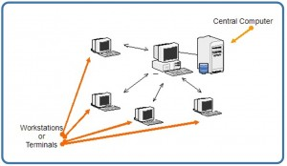

* **Distributed Database System:**

A distributed database system (DDBMS) is a type of database management system in which the database is spread across multiple interconnected computer systems or nodes. Unlike a centralized DBMS, where all data is stored on a single server, in a distributed system, data is distributed across multiple servers or nodes that are connected via a network.

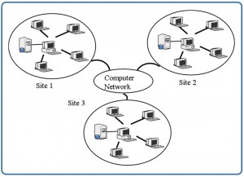

* **Homogenous Distributed Database System:**

Homogeneous distributed database systems refer to a type of distributed database system where all nodes or sites in the distributed network use the same DBMS software and have identical database schemas. In other words, the data model, schema, and DBMS software are consistent across all nodes in the distributed system.

* **Heterogeneous Distributed Database System:**

Heterogeneous distributed database systems refer to a type of distributed database system where multiple nodes or sites in the distributed network use different DBMS software and may have varying database schemas.

**Application of DBMS: -**

### 1. Railway and Airline Reservation System

The database keeps a record of ticket booking, arrival time, departure time, delays, and even seat numbers of airplanes or trains.

### 2. Library Management System

There can be tens of thousands of books in a library, so it becomes very important to keep a record of the details of each book. Handwritten records can prove to be a real hassle when managing literally thousands of books. DBMS comes into play here, all the details of each book - name, author, number of pages, availability, quantity, etc., can be managed using a Database Management System.

### 3. Banking

An uncountable number of bank transactions and deposits are made, thousands of new bank accounts are created daily, and many such things. This is all possible because of a Database Management System that makes keeping track of the record much easier.

### 4. Education Sector (Schools and Colleges)

The details of each student, teacher, and even janitor are stored in a database to manage the information easily.

### 5. Social Media Sites (Instagram, Facebook, etc.)

Social media websites like Instagram, Facebook, Whatsapp, etc., are able to keep track of each and every detail of their users (name, phone number, photos, email address, password, etc.) with the help of Database Management Systems.

### 6. Online Shopping (E-commerce Platforms Like Amazon)

With time, more and more people have started shopping online, no one wants to go to a shop and waste their time when they can do the same thing while at home and save time. With the increase in online shopping customers, there's a need to store their details efficiently.  
That is why, all the details of the customers, products as well as order and tracking details are stored and managed using a Database Management System.

**RDBMS**

A Relational Database Management System (RDBMS) is a type of database management system (DBMS) that stores and manages data in a structured format based on the relational model. In an RDBMS, data is organized into tables with rows and columns, where each row represents a unique record and each column represents a specific attribute of that record. Relationships between tables are established using keys, primarily primary keys and foreign keys.

* Relational Database Management Systems replicate the following characteristics in order to preserve data integrity:
* Entity Integrity: A database table cannot have two identical records.
* Referential Integrity: Only those table rows that are not used by any other table can be removed. If not, inconsistent data can result.
* Individually specified Integrity: User-defined guidelines for access and confidentiality.   
  Domain integrity: Based on default values, data types, or ranges, the database tables' columns are contained inside certain structured bounds.

| **DBMS** | **RDBMS** |
| --- | --- |
| [DBMS](https://www.geeksforgeeks.org/introduction-of-dbms-database-management-system-set-1/) stores data as file. | [RDBMS](https://www.geeksforgeeks.org/rdbms-architecture/) stores data in tabular form. |
| Data elements need to access individually. | Multiple data elements can be accessed at the same time. |
| No relationship between data. | Data is stored in the form of tables which are related to each other. |
| Normalization is not present. | Normalization is present. |
| DBMS does not support distributed database. | RDBMS supports distributed database. |
| It stores data in either a navigational or hierarchical form. | It uses a tabular structure where the headers are the column names, and the rows contain corresponding values. |
| It deals with small quantity of data. | It deals with large amount of data. |
| Data redundancy is common in this model. | Keys and indexes do not allow Data redundancy. |
| It is used for small organization and deal with small data. | It is used to handle large amount of data. |
| Security is less | More security measures provided. |
| It supports single user. | It supports multiple users. |
| Data fetching is slower for the large amount of data. | Data fetching is fast because of relational approach. |
| The data in a DBMS is subject to low security levels with regards to data manipulation. | There exists multiple levels of data security in a RDBMS. |
| Low software and hardware necessities. | Higher software and hardware necessities. |
| Examples:[XML](https://www.geeksforgeeks.org/xml-basics/), Window Registry, dbaseIIIplus etc. | Examples: [MySQL](https://www.geeksforgeeks.org/architecture-of-mysql/), [PostgreSQL](https://www.geeksforgeeks.org/what-is-postgresql-introduction/), [SQL](https://www.geeksforgeeks.org/what-is-sql/) Server, Oracle, Microsoft Access etc. |

**Structured Query Language (SQL)**

A relational database can be processed and stored using the programming language SQL. Information is stored in tabular form in relational databases, where distinct data properties and the numerous relationships between the data values are represented by rows and columns. Information can be stored, updated, removed, searched for, and retrieved from databases using SQL commands. SQL can also be used to optimize and maintain database performance.

Structured Query Language is a widely used query language that finds regular use in several application domains. SQL is a language that developers and data analysts learn and use because it works well with a variety of programming languages.

For example, they can use popular SQL database systems like Oracle or MS SQL to create high-performing data processing applications by integrating SQL queries with Java programming.

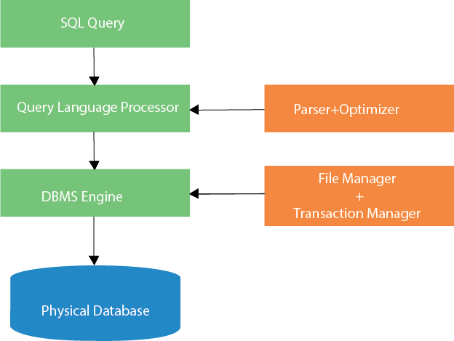

SQL and MySQL are not interchangeable. Note that one of the most well-known RDBMS software brands that uses a client-server architecture is MySQL.  
In an RDBMS context, the client and server converse using Structured Query Language (SQL), a domain-specific language.

If you come across other names that contain SQL, such as Microsoft SQL Server and PostgreSQL, they are probably brands that also employ the syntax of Structured Query Language. Although RDBMS software is sometimes created in multiple programming languages, SQL is always used as the main language for database interaction. It is written in C and C++ for MySQL itself.

**SQL Commands**

SQL commands are the backbone of interacting with relational databases, providing a versatile toolkit for managing and manipulating data.

These commands can be broadly categorized into several types:

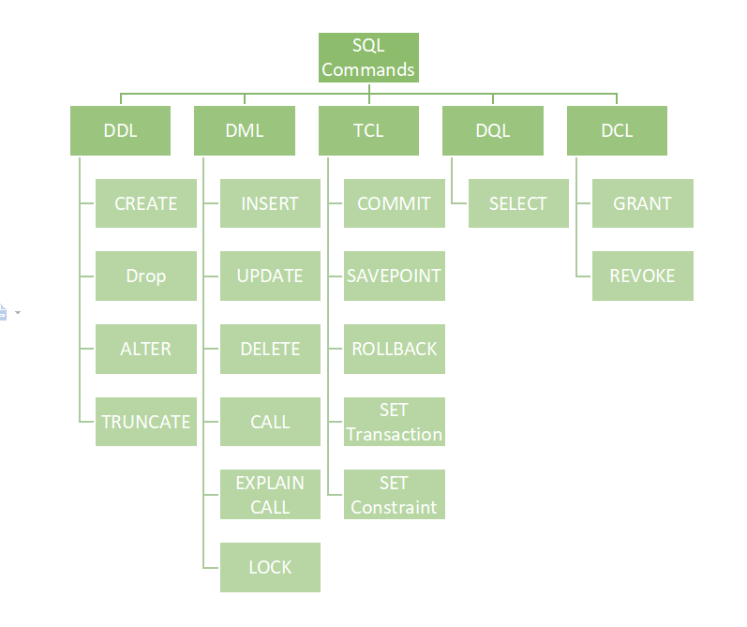

1. **Data Definition Language (DDL):**

DDL commands are used to define, modify, and delete database objects such as tables, indexes, and views. Examples include:

- `CREATE TABLE`: Defines a new table.

- `ALTER TABLE`: Modifies the structure of an existing table.

- `DROP TABLE`: Deletes a table and its data.

1. **Data Manipulation Language (DML):**

DML commands are used to manipulate data within database objects. These include:

- `SELECT`: Retrieves data from one or more tables.

- `INSERT INTO`: Adds new records into a table.

- `UPDATE`: Modifies existing records in a table.

- `DELETE FROM`: Removes records from a table.

1. **Data Control Language (DCL):**

DCL commands are used to manage access privileges and permissions. Examples include:

- `GRANT`: Provides specific privileges to users or roles.

- `REVOKE`: Removes privileges from users or roles.

1. **Data Query Language (DQL):**

DQL commands are used exclusively for querying data. The primary command is `SELECT`, which allows for complex retrieval of data based on specified criteria.

1. **Data Transaction Control (DTC):**

DTC commands are used to manage transactions within the database, ensuring data integrity. Examples include:

- `COMMIT`: Saves all changes made during the current transaction.

- `ROLLBACK`: Reverts all changes made during the current transaction.

SQL commands form the foundation for interacting with databases, providing the means to create, modify, retrieve, and manage data efficiently and securely.

**SQL Datatypes**

SQL supports a variety of data types that allow you to define the type of data that can be stored in each column of a table. These data types can be broadly categorized into several groups:

**1. Numeric Types:**

- `INT` (Integer): Represents whole numbers.

- `FLOAT` or `REAL`: Represents floating-point numbers with decimal precision.

- `DOUBLE`: Represents double-precision floating-point numbers.

- `DECIMAL` or `NUMERIC`: Represents fixed-point numbers with decimal precision.

2. **Character String Types:**

- `CHAR(n)`: Fixed-length character string with a specified length 'n'.

- `VARCHAR(n)`: Variable-length character string with a maximum length 'n'.

- `TEXT`: Variable-length character string with a maximum length determined by the database.

**3. Binary Data Types:**

- `BINARY(n)`: Fixed-length binary string with a specified length 'n'.

- `VARBINARY(n)`: Variable-length binary string with a maximum length 'n'.

- `BLOB`: Binary Large Object for storing large binary data such as images or documents.

**4.** **Date and Time Types:**

- `DATE`: Represents a date (YYYY-MM-DD).

- `TIME`: Represents a time (HH:MM: SS).

- `DATETIME`: Represents a combination of date and time (YYYY-MM-DD HH:MM: SS).

- `TIMESTAMP`: Represents a timestamp, often used for recording the date and time of data modification.

**5. Boolean Type:**

- `BOOLEAN`, `BOOL`, or `BIT`: Represents Boolean values, typically 'TRUE' or 'FALSE'.

**6. Other Types:**

- `ENUM`: Represents a set of predefined values.

- `SET`: Represents a set of values chosen from a predefined list.

These are some common data types supported by most SQL database systems, but specific implementations may offer additional types or variations. Choosing the appropriate data type for each column in your database tables is important for data integrity, storage efficiency, and query performance.

**SQL Workbench**

Database architects, developers, and database administrators can collaborate with one another using MySQL Workbench, a unified visual database designing or graphical user interface tool. Oracle develops and maintains it. In addition to offering extensive administrative tools for server configuration, user management, backup, and many other tasks, it also offers SQL creation, data modelling, and data movement. This server administration can be used to generate SQL (execute queries, etc.) and to create new physical data models and E-R diagrams. All popular operating systems, including Windows, Linux, and Mac OS, are compatible with it. Versions 5.6 and higher of MySQL Server are fully supported by MySQL Workbench.